Cyber Crime and Digital Evidence
Triage and Analysis with KAPE
Week 34



Submitted by:
Full Name: Anish Adhikari
Orbund ID : 11147
Student ID : 24071101
Kathmandu, Nepal

4.1.1 FileFolderAccess Analysis

- Was there any user interaction on this machine with an optical disk drive? If yes, when did that happen? (exact timestamp; e.g. 17/02/2021 17:02:34 TIMEZONE)

Ans: Yes there was a user interaction with an optical disk drive. The interaction is
evidenced by shortcut (.lnk) files tagged as optical disk, which show a last
accessed timestamp of 6/3/2002 07:53 (GMT).
This indicates that the user accessed optical disk–related content on the machine
at that exact time.

Fig: Interaction with Optical disc

- Was there any user interaction on this machine that shows that an index.htm file was stored in a removable storage media? If yes, which day the interaction happened? (e.g. 17/02/2021 TIMEZONE)
Ans: Yes, there was user interaction showing that an index.htm file was stored on
removable storage media. This interaction occurred on 06/03/2002 20:05:20
GMT.

Fig: Interaction of index.htm file

- Was there any user interaction on this machine that shows access to a folder created by an Online Service? When did this happen? (exact timestamp(s), e.g. 17/02/2021 17:02:34 TIME- ZONE )

Ans: Yes, there is evidence of user interaction showing access to folders created by
America Online (AOL), an online service at the time. This is indicated by multiple
shortcut (.lnk) files in the Recent folder pointing to paths under F:\Program
Files\America Online 7.0\download (e.g., zip files, log files, and the download
folder itself). These shortcuts were created when the user accessed the target files
or folder, serving as artifacts of interaction.

The interactions occurred at the following exact timestamps:
5/14/2002 17:10:49 GMT(access to the download folder)
5/14/2002 17:12:59 GMT (access to Hunter.log in the download folder)
5/14/2002 17:26:04 GMT (access to hourz11.zip in the download folder)
5/14/2002 17:26:24 GMT (access to CURREX~1.zip in the download folder)
6/5/2002 00:24:33 GMT (access to Special Interests - Tech Chat.log in the
download folder)

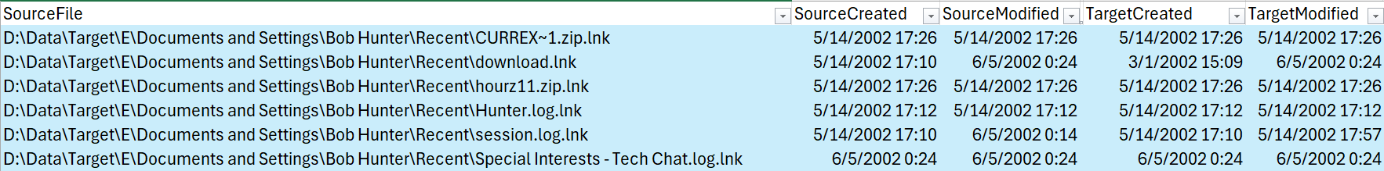Fig: Access to the folder created by Online Services
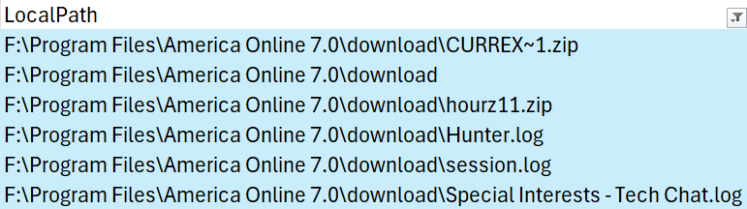Fig: LocalPath of the associated files

- Was there any user interaction that shows a zip file was stored in a folder? If yes, which folder? When this particular folder was last accessed? (exact timestamp; e.g. 17/02/2021 17:02:34 TIMEZONE)

Ans: This is evidenced by the shortcut file 103-0356_IMG.zip.lnk, which targets the ZIP
archive F:\Hunter Pics\103-0356_IMG.zip. This confirms that the ZIP file was stored
within the Hunter Pics folder and was accessed by the user. The Hunter Pics folder
was last accessed on: 06/03/2002 21:22:13 GMT.

Fig:
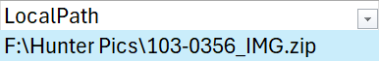
Fig: Local path of the file

4.1.2 ProgramExecution Analysis

1. When Internet Explorer was last run? (exact timestamp; e.g. 17/02/2021 17:02:34
TIMEZONE)

Ans: Internet Explorer was last run on 6/4/2002 23:40:28 GMT.
Fig: Internet Explorer Prefetch file
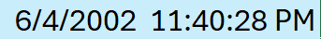
Fig: Last Run Time of IEXPLORER.EXE

2. What was the name of last executable file that was run on this computer? What
is this file related with?

Ans: The last executable file that was run on this computer was IMAPI.EXE on
6/5/2002 00:40:02 GMT. IMAPI.EXE is a Windows system file that helps burn
CDs and DVDs.

Fig: Last executable that ran on the computer
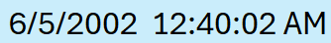
Fig: Last Run Time of IMAPI.EXE

3. Which 2 programs that were used in the last 3 days were mostly run in this
system?

Ans: The two programs used most in the last 3 days were IMAPI.EXE (22 times) and
RUNDLL32.EXE (20 times).

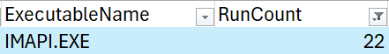
Fig: IMAPI.EXE executed 22 times

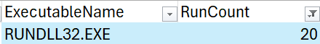
Fig: RUNDLL32.EXE executed 20 times

4. Did this user attempt to access his/her emails in these last three days? If yes,
when did this happen? (exact timestamp; e.g. 17/02/2021 17:02:34 TIMEZONE)

Ans: Yes, the user attempted to access their email in the last three days. This
occurred on 6/5/2002 00:07:59 GMT, when AOL.EXE was executed, which
corresponds to the last login date.

Fig: AOL.EXE details

